**What is blockchain?**

Blockchain is a cryptographic technology; it began with Bitcoin (BTC) in 2008 when Satoshi Nakamoto released its whitepaper. Blockchain uses a decentralised, immutable distributed ledger which keeps track of all transactions in the network.

Bitcoin is primarily used for making payments, and is a store of value like gold or fiat currency; however, unlike gold, it has no physical value, and unlike fiat, it is not backed by the Government.

**The Bitcoin Transaction Cycle:**

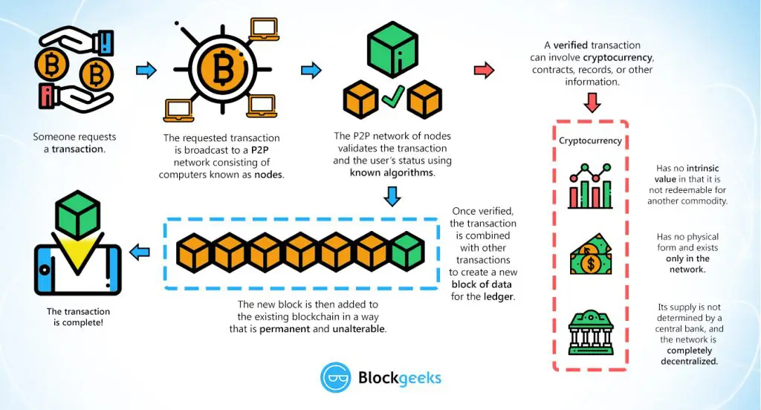

(Blockgeeks, 2016)

After Bitcoin's adoption, new cryptocurrencies entered the market, such as Ethereum (ETH), which is a programmable blockchain, supporting DApps and Smart Contracts. These new coins are called Altcoins, short for "Alternative Coins".

New currencies called tokens emerged, many operating on other blockchains networks such as Ethereum (called ERC20 tokens), and others having their own blockchain.

There are a variety of different types of cryptocurrencies besides those intended for payment:

* **Privacy coins** such as Monero focus on making payments in a way which cannot be tracked back to the user.
* **Gambling coins** which are used by online crypto casinos to play games on the blockchain.
* **Voting coins** which enable users to vote digitally in a reliable manner.
* **Energy coins** which allow users to buy and sell electricity peer-to-peer.
* **Supply chain coins** which track information about a product in the supply chain.
* **Stable coins** such as Tether are pegged to fiat to reduce volatility.
* **Exchanges tokens** are commonly offered by exchanges for use on their platform, which provide some perks such as reduced trading fees.
* **Ad revenue tokens** such as BAT which pay you for watching ads and allow you to tip content creators on the web. (This token is integrated with the Brave browser.)
* **Decentralised Finance coins** enable users to take out loans and more.

(Types of cryptocurrencies: explaining the major types of cryptos, 2019)

China is working on a cryptocurrency of their own which is backed by gold. (Bloomberg - China's Digital Currency Could Challenge Bitcoin and Even the Dollar, 2020). This is a form of Government-endorsed digital currency which may be commonplace in the future.

It is rumoured that PayPal and Venmo may be planning on allowing the buying, selling and storing of cryptocurrencies. (Allison, 2020). If this turns out to be accurate, this will significantly increase adoption and simplify the process for people to get into cryptocurrency.

Another crypto called Lolli is partnering with a number of retailers online to provide cashback in the form of Bitcoin in order to increase adoption and get more people into the crypto space. (Crichton, 2018)

**Wallets**

Typically, a crypto wallet consists of two important addresses: a public address (akin to an account and BSB number in a bank), to which others send funds; and, a private key (or address) which is like a bank account's username and password. Whoever owns the private key has access to the wallet, and can transfer the funds inside. Transactions are irreversible.

Wallets can be created via legitimate websites, smartphone apps, or even hardware devices. The concern with digital wallets is you are potentially vulnerable to viruses, malware and hacking, although they are very convenient. Physical hardware wallets offer much more security in comparison but are not free.

**What does blockchain aim to do?**

Blockchain aims to remove the middleman: when we make payments online, we use our bank, or services such as PayPal; however, if these services are not available at that time, we are unable to do anything. The focus of blockchain is on decentralised processing and validation; essentially, removing that middle man from the equation, but still ensuring that both parties get what they agreed.

There are various types of validation found in blockchain projects:

**Proof of Work (PoW)**

This type of validation is used by Bitcoin, Ethereum and many other coins. Transactions are gathered into blocks; these blocks are then linked together.

Miners try to solve a cryptographic hash which gives them the right to add the next block to the chain; it is this mechanism that keeps the network safe. One potential issue with this form of validation is if one entity owns 51% of the mining network; this allows for that entity to decide whether transactions are legitimate or not.

Miners often join "pools" which are large networks of miners who work together to solve the hash; rewards are divvied out proportionally based on a miner's contribution.

**Proof of Stake (PoS)**

Coin holders lock their coins in the system; the system then decides which of the holders will validate the next block. The more coins that are staked, the higher the odds of being chosen.

**Delegated Proof of Stake (DPoS)**

Coin holders lock their coins in the system, providing them with a proportional amount of voting power; holders vote for a delegate who manages the blockchain, ensuring security and consensus. (What Is Staking? | Binance Academy, n.d.)

**What could blockchain do over the next few years?**

**Supply chain authentication**

Various cryptocurrencies focus on supply chain authentication. The goal is to prove the authenticity of products and provide information about their journey along the supply chain, as well as additional potentially relevant information such as: when it was packed, where it was packed, and by whom was it packed.

According to Peili (2019) at CoinCodex the top 5 cryptocurrencies in this field include: WaltonChain (WTC); Modum (MOD); VeChain (VET); Ambrosus (AMB); Tael (WABI).

In the coming years, we may see these cryptocurrencies begin to gain traction in consumer markets and provide consumers with the confidence that their product is indeed what is advertised.

Supply chain authentication is a big deal in China due to the large number of counterfeit products that are sold across a range of categories such as food, beverages, footwear, apparel, technology and many more.

In 2013, the global trade for counterfeit products reached half a trillion dollars, with most of the counterfeit being produced in China or Hong Kong. (Global trade in fake goods worth nearly half a trillion dollars a year - OECD & EUIPO - OECD, 2016)

It has recently been announced that Chase Shiel in Australia will be using VeChain to confirm the authenticity of its Nike shoes. According to the article, knockoff shoes are a big issue for footwear makers. (Toshendra Sharma, 2020)

Ubique Chain of Things (UCOT) is one blockchain that aims to revolutionise supply chain tracking.

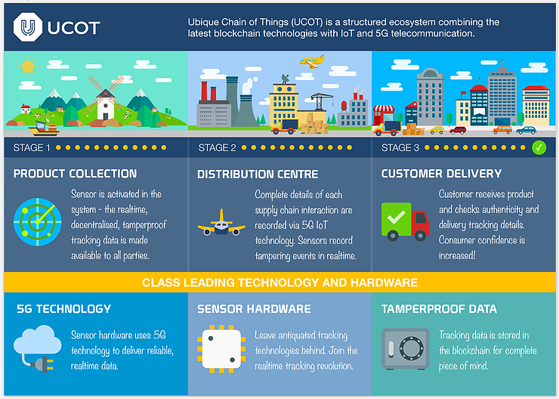

(UCOT, 2018)

**Gambling**

Another aspect which blockchain aims to improve is gambling. Blockchain removes the element of trust from the equation. Is the house cheating? Is a player cheating? Everything is recorded on the blockchain, which means everything can be audited. (Goryunov, 2020)

FunFair (FUN) is an example of a coin which can be used in an online casino made by the same company, allowing users to gamble on the blockchain.

**Voting**

An important issue which involves trust is voting. Some concerns with the existing system are that it is expensive to run a vote and that it is unreliable. Moving voting to the blockchain means all votes are verifiable, there is no time spent counting ballots and the costs are far, far cheaper.

Two companies that focus on this field include Horizon State and FollowMyVote.

**Payments**

Cryptocurrencies are competing with each other to become the most popular for payments and to outperform credit card systems.

One of the most significant benefits of blockchain in the field of payments is the ability to pay someone anywhere in the world without a middle man. However, at this stage, transaction speeds are not fast enough – ranging from minutes to hours.

In the future, we will see transactions that can be processed in a matter of seconds, securely between two parties.

**Private payments**

Because the blockchain is public, meaning anyone can view it and follow a trail of transactions, that means there is a need for privacy. Privacy coins such as Monero do this by obfuscating the buyer's public address. (A low-level explanation of the mechanics of Monero vs Bitcoin in plain English, n.d.)

**For a visual overview of the blockchain ecosystem see the graphic below:**

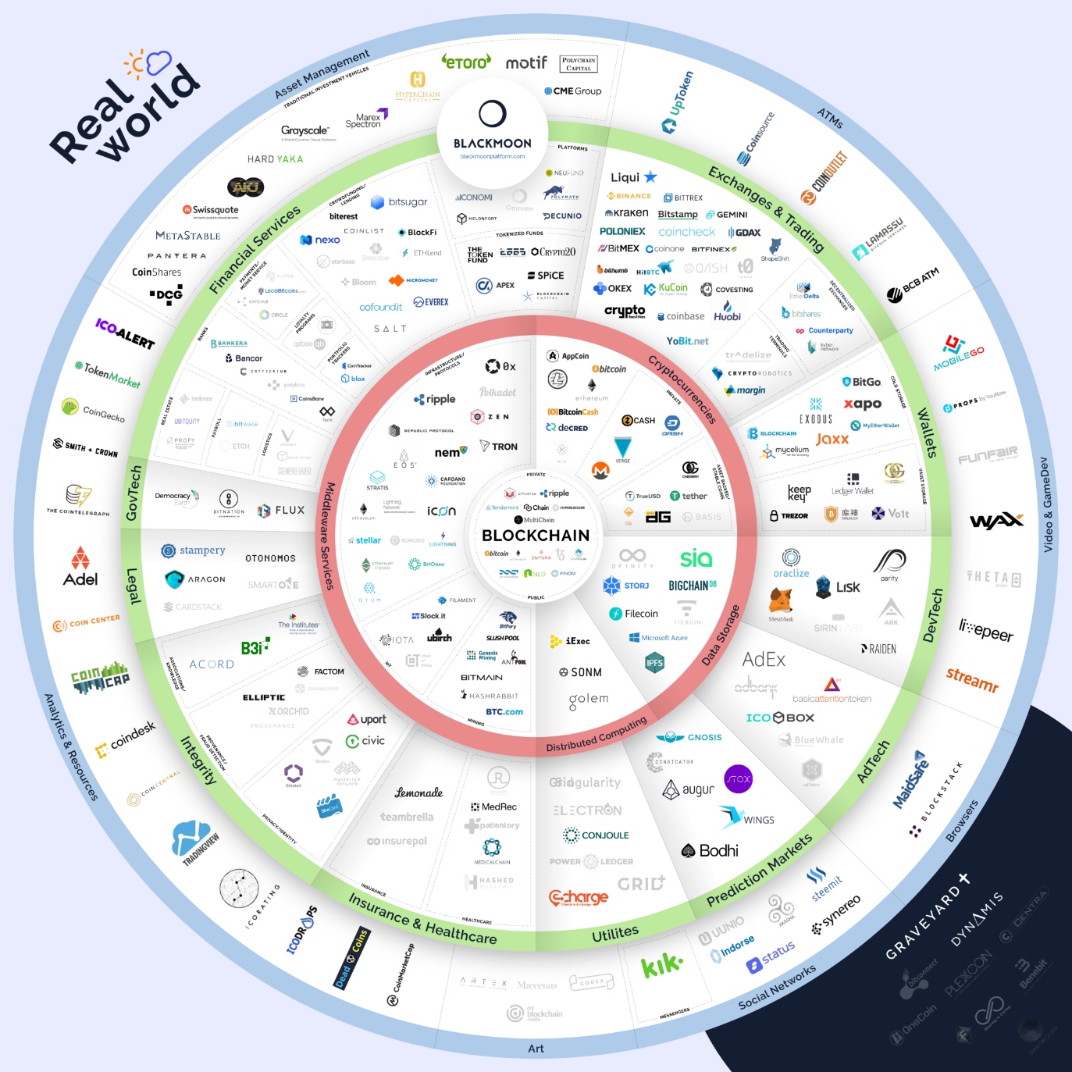

(Blackmoon, 2018)

**How will this affect society?**

The overall impact of the blockchain will vary depending on the particular field in which it is being employed.

In supply chain management, counterfeit products will be purchased less as consumers can verify the authenticity of genuine goods; this will help consumers stay away from potentially dangerous, counterfeit products. Over time, the massive market for counterfeit products will decrease.

With food products, consumers will be able to see if the product is organic, where it was grown and much more.

In payments, as improvements to the technology occur, people will be able to complete high-speed transactions across the globe for tiny fees without reliance on any middle man.

In terms of voting, there are many benefits, including:

* Voting from any device in your own home
* Secure voting that anyone can audit
* Ability to change your vote easily
* Reduced costs for vote-holders, making votes more practical and economical

In 2017 the Australian Government conducted a postal survey to ask citizens whether or not gay marriage should be legalised. The survey cost 122 million dollars which is an enormous figure. (Australia: 'Yes' Vote to Marriage Equality | Human Rights Watch, 2017)

With a substantial reduction in cost, more votes can be held to allow a country's citizens to weigh in on important issues; whereas, right now, it is not fiscally viable to do so.

Blockchain is gaining more and more adoption, and in turn, companies are hiring more and more developers; this creates many job opportunities in an emerging market.

The use of blockchain in banking, and a full move to digital currency, may make bankers and tellers are a thing of the past.

**References**

Monero.how. n.d. *A Low-Level Explanation Of The Mechanics Of Monero Vs Bitcoin In Plain English*. [online] Available at: <https://www.monero.how/how-does-monero-work-details-in-plain-english> [Accessed 29 June 2020].

Allison, I., 2020. *Paypal, Venmo To Roll Out Crypto Buying And Selling: Sources - Coindesk*. [online] CoinDesk. Available at: <https://www.coindesk.com/paypal-venmo-to-roll-out-crypto-buying-and-selling> [Accessed 29 June 2020].

Human Rights Watch. 2017. *Australia: 'Yes' Vote To Marriage Equality | Human Rights Watch*. [online] Available at: <https://www.hrw.org/news/2017/11/15/australia-yes-vote-marriage-equality> [Accessed 29 June 2020].

Capital.com. 2019. *Types Of Cryptocurrencies: Explaining The Major Types Of Cryptos*. [online] Available at: <https://capital.com/types-of-cryptocurrencies> [Accessed 29 June 2020].

Crichton, D., 2018. *Techcrunch - Lolli Launches To Give You Free Bitcoin While You Shop*. [online] Techcrunch.com. Available at: <https://techcrunch.com/2018/08/22/lolli-launches-to-give-you-free-bitcoin-while-you-shop/> [Accessed 5 July 2020].

sofi. n.d. *Understanding The Different Types Of Cryptocurrency*. [online] Available at: <https://www.sofi.com/learn/content/understanding-the-different-types-of-cryptocurrency/> [Accessed 29 June 2020].

Peili, R., 2019. *Top 5 Supply Chain Management Cryptocurrencies | Coincodex*. [online] Coincodex.com. Available at: <https://coincodex.com/article/4925/top-5-supply-chain-management-cryptocurrencies/> [Accessed 5 July 2020].

Bloomberg.com. 2020. *Bloomberg - China'S Digital Currency Could Challenge Bitcoin And Even The Dollar*. [online] Available at: <https://www.bloomberg.com/news/articles/2020-06-01/china-is-making-cryptocurrency-to-challenge-bitcoin-and-dollar> [Accessed 5 July 2020].

Goryunov, M., 2020. *Blockchain And Gambling*. [online] 3commas Cryptocurrency Blog - Trading Guides and Tutorials. Available at: <https://3commas.io/blog/blockchain-and-gambling> [Accessed 5 July 2020].

Oecd.org. 2016. *Global Trade In Fake Goods Worth Nearly Half A Trillion Dollars A Year - OECD & EUIPO - OECD*. [online] Available at: <http://www.oecd.org/industry/global-trade-in-fake-goods-worth-nearly-half-a-trillion-dollars-a-year.htm> [Accessed 5 July 2020].

Sharma, T., 2020. *Vechain To Verify The Authenticity Of Non-Genuine Nike Shoes*. [online] Blockchain-council.org. Available at: <https://www.blockchain-council.org/blockchain/vechain-to-verify-the-authenticity-of-non-genuine-nike-shoes/> [Accessed 5 July 2020].

Blackmoon, 2018. *The Blockchain Ecosystem*. [image] Available at: <https://news.blackmooncrypto.com/the-blockchain-ecosystem-v3-six-months-after-the-hype-ca14e9879001> [Accessed 9 July 2020].

UCOT, 2018. *UCOT Supply Chain Ecosystem*. [image] Available at: <https://medium.com/ucot/ucot-to-put-an-end-to-fake-and-counterfeit-medicines-1a46918dcb3a> [Accessed 9 July 2020].

Blockgeeks, 2016. The Bitcoin Transaction Process. [image] Available at: <https://blockgeeks.com/guides/what-is-blockchain-technology/> [Accessed 9 July 2020].

Binance Academy. n.d. *What Is Staking? | Binance Academy*. [online] Available at: <https://academy.binance.com/blockchain/what-is-staking> [Accessed 29 June 2020].